Student next assignment submission prediction using machine learning approach

¹Mushtaq Hussain, ¹Prof: Zhang Wu, ¹Wenhao Zhu, ¹Muhammad Raza Abidi, ²Sadiq Hussain, ³Zaheer Ullah Khan

¹School of Computer Engineering and Science, Shanghai University, China
²System Administrator,Dibrugarh University, Dibrugarh, Assam, India
³Nanjing University of Aeronautics &Astronautics, China

New paper

Old paper

Abstract
The web-based learning platform provides quality education in nowadays, but course drop out is a critical issue in this system. Therefore to detect dropout student in advance before the end, of course, is an important problem. In the current study, we predict the next assignment submission of the student, which detect the student course dropout before the end of course. Mostly the previous machine learning (ML) method is based on time-consuming processing such as feature extraction and preprocessing. But the current study model base on convolution neural network (CNN) which automatically do feature extraction

Keywords: Convolution neural network, dropout prediction, feature extraction,

Introduction

In current study, we used Convolution neural network (CNN) to developed productive model because it do automatically feature extraction from raw data and required less features extraction effectors as compare to other ML methods.

Along with the advantages of e-learning, students also have some challenges; for example, students in e-learning systems have the opportunity to attend different sessions or weeks, where each session or week focuses on a particular topic. If the instructor does not receive feedback from each session or week, the students may drop or fail the course. Therefore, it is important for the instructor to understand their students’ performances for each week or session.
There are many ways to find the sessions or weeks that prove beneficial to learning. For example, one method is to conduct a survey; however, most surveys are not scalable to online course levels.

The goal of this study is to identify which sessions are most beneficial to a student’s performance in an e-learning system based on that student’s engagement, workload, difficulty, and loyalty. We also investigate the relationship between the session-independent variables (i.e., engagement, workload, difficulty, and loyalty) on a dependent variable (i.e., student session score). For this, we used a machine learning (ML) techniques to identify the pertinent information in an e-learning system.
ML algorithms are appropriate for identifying the beneficial student sessions. Using ML tools, teachers can automatically detect the beneficial sessions. The teacher can consider this student’s assignments for the non-beneficial sessions to identify which student materials are most helpful. Consequently, an instructor can ideally evaluate each session to understand their students’ progress.The proposed framework can be easily integrated into the digital electronics education and design suite (Deeds) (https://www.digitalelectronicsdeeds.com/) or other e-learning systems to identify session beneficence.

In the current study, we used student data collected by the technology-enhanced learning (TEL) tool in Deeds. Deeds is a web-based system that allows students to complete different course exercises. When completing these exercises, the students read material and perform different activities (Vahat et al. 2015). It is difficult to differentiate the beneficial sessions from a student’s mental state because such differentiation depends on the nature of the course material, exercises, and activities—and every student has a different mental state. However, other factors can also affect the session beneficially, such as the instructor’s teaching style and teaching experience. We performed a two-class classification to identify was beneficial and non-beneficial sessions.

In this study, we applied a regression analysis to identify the hidden factors that are closely related to student session scores. The results showed which sessions resulted in students reading more and increased visits to the Deeds system. Next, we modeled the beneficial session problem and identified the ML classifier that can accurately find beneficial sessions. Finally, we used high-accuracy classifiers to obtain the beneficial sessions during an e-learning session.

We can conclude that 1) deep learning (DL) and random forest (RF) models achieved high accuracy in predicting student and session beneficial compared to other models and 2) through a regression analysis, we find that student engagement and loyalty are highly correlated with student session scores.

Research questions

This study was designed to answer the following research questions:
- During web-based system session, do engagement, difficulty, workload, and loyalty have significant impacts on session score?
- Is it possible to use ML approach to identify the beneficial sessions in an e-learning course?
The paper is divided into the following sections: Section 2 provides the problem description for the current study. Section 3 reviews the related previous works on session beneficence in e-learning systems. Section 4 describes the details of the material and techniques used in the study. Section 5 presents and discusses the experimental results. Finally, Section 6 provides conclusions and outlines future work.

Problem Description

In this study, we used student activities data in VLE to predict, is student submit course next assignment
In the current study, we developed binary classification model that classifies sessions as beneficial or non-beneficial; consequently, its results can help improve the skills of weak students. We used the ML models RF, DL, logistic regression (LR), gradient boosted tree (GBT), generalized linear model (GLM) and naïve Bayes (NB) classifiers to detect the beneficial sessions.

Related Work

Mostly, there are two main ML methods used in previous work to predict the student dropout rate, one is general traditional method which used common data mining and machine learning technique such as SVM and ANN etc and other is used Deep learning techniques.
3.1 Deep learning techniques
The deep learning (DL) is used in many fields and gets better result. It is also used in education to predict student performance and other pattern of student

Guo 2010 detected course satisfaction using an artificial neural network (ANN) based on student survey data. The results conclude that course satisfaction is strongly correlated with the number of students in the course and a high distinction rate in the grades achieved. Casey and Gibson (2010) examined the correlation between student activities and exam results in master courses in the modular object-oriented dynamic learning environment (Moodle). The study concluded that daily course views and activity level are good indicators of student performance. Mutahi et al. (2017) studied the relationship between student and instructor content interactions and found that most instructors did not focus on study materials that students regularly visited. Atherton et al. (2017) concluded that students who regularly access the course materials are likely to achieve high grades. Cuesta (2010) espoused a practical approach to online course design. The author discussed various issues and features related to the design and implementation of course materials and suggested using componentized materials and continual efforts to properly implement educational strategies helpful to both students and online instructors.
Kardan et al. (2013) investigated the student course satisfaction problem. The study concluded that neural networks are optimal models for predicting student satisfaction and course time factors and that the time of the final examination may affect student’s course decisions. Whitelock et al. (2015) discussed student workload management. A new module designer should incorporate learning design management to allow input and display of the number of hours allotted to a course. Distance learners often have limited time and the probability of dropout increases when learners cannot cope with the required coursework. They also recommended that an automatic feedback system could help time-poor students when completing assignments. Krnel and Barbra (2009) addressed the importance of appropriate materials in the e-learning field. Arnold et al. (2005) computed student sessions from online courseware consisting of 500 learning pages with varied lengths and difficulties. They surprisingly discovered that session control and page difficulty did not play significant roles in determining the average time students spend on a given learning page. However, mood, proximity, and deadlines played important roles in this area. They also found that students spent less time on various learning pages in the latter part of the semester. Scheuer and Zinn (2007) devised a tool called ‘Student Inspector’ to track student sessions in an e-learning environment. In a traditional system, teachers can communicate with their students directly; thus, they can help the students optimize their potentials. However, e-learning environments have little or no direct human-to-human communication. They evaluated the tool’s functionality for tracking student sessions. Hussain et al. (2018) proposed a learning analytics model based on big data. The data scattered among different departments of the institutions collectively comprises big data for the education sector. Based on various student records, the model may recommend a course suitable for the student. This model may be helpful to both educational institutions and data-driven decisions. Darmody et al. (2008) addressed the issue of student workload in different fields in higher education.

In summary, a variety of studies have been undertaken to solve session and course beneficence and satisfaction problems using data mining and statistical techniques. In the above-related work, the session beneficial is mostly calculated through statistical methods that are not scalable and not easily understandable for the instructors. This study focuses on the impacts of student workload, engagement, difficulty, and loyalty on session scores and finds which sessions are most beneficial for students to achieve high grades.

Materials and Methods

4.1 Data Description and Study Context

In this section, we provide details of the data used in the current study. The data are the collection of exercises, activities, times and clicks on activities and exercises. For this study, we used a student dataset collected from a digital design course delivered in Deeds. The digital design courses are taught in four Deeds sessions. Each session consists of a different “chapter” of the digital design course designed by the instructor. In every session, the students obtain some score after completing the exercises for that session. Lab exercises involve circuit simulation. The course material is supplied in the shape of activities that the students perform while solving the exercise. The student’s score is obtained via a session based on the exercises in the sessions. We can mine the learning analytics data for this educational process, which is stored in the UCI machine learning repository (Murphy and Aha, 1995).
In this study, 107 students participated in different sessions of the digital design course, which is taught in four Deeds sessions. In each session, students perform different activities to complete different digital design courses. All these activities are recorded in the log file.

4.2 Current study Methods

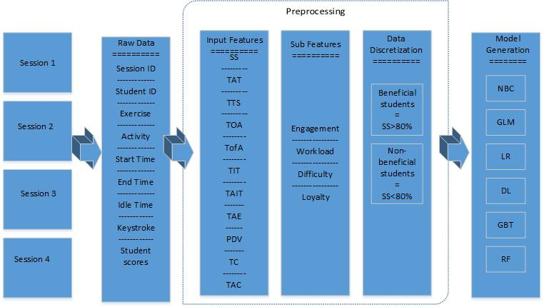
Figure 1. Basic steps in the current study models

In this section, we provide details about the ML methods and regression techniques used to efficiently identify beneficial sessions in the e-learning system. Figure 1 shows the basic steps of the current study. The proposed framework of the current study includes the following tasks.

4.2.1 Data processing

To build ML models, both a predictor and label are necessary. The raw data used in the current study do not contain predictors and labels; therefore, we conduct preprocessing that extracts predictors and labels suitable for the ML models. The preprocessing is important for improving the value of the dataset. The preprocessing involved multiple steps, as follows

4.2.1.1 Feature extraction
First, we extract features from the raw data of every session that are closely related to student session beneficence. Every session dataset contains a feature vector along with labels. Their details are shown below:
Session scores (SS) are the scores students achieved after completing the different session exercises and activities during the course. Total Average Time (TAT) contains the average time spent by the user on the session’s activities and exercises in each session. Total time in the session (TTS) contains the total time student spent on the session during the course. Total On-task Activities (TOA) shows the number of on-task activities performed by a student during the course session. High-score students primarily performed on-task activities during the session, for example, reading course-related materials, solving course exercises, etc. Total Off-task Activities (TofA) holds the number of off-task activities students performed during the session. Some students perform off-task activities during a session such as browsing Facebook, Twitter, etc. Total idle time (TIT) shows the student’s total idle time during the session, and Total average Idle time (TAIT) captures the total average idle time of the student during the session. Total activity/exercise (TAE) shows the number of activities and exercises solved by a student during the session. Per Day Visits (PDV) shows the per-day student logins to the Deeds system to complete exercises and perform various activities. Total clicks (TC) shows the total number of clicks a student performed during a session, while Total average Clicks (TAC) shows the average number of clicks a student performed during the session

4.2.2.2 Data discretization and label assignment

In ML, labeling is an important step. After extracting the above features from the raw data of all 4 sessions, we assigned a label to each input feature, creating new input features that included engagement, workload, difficulty, and loyalty. The details of these sub attributes are as follows:

Engagement: Multiple definitions of engagement appear in the literature. For example, one definition of student engagement is the effort a student spends when learning the course material (Coate, 2006). According to Stovall (2003), student engagement measures how well students spent their time when taking part in course activities. In our scenario, engagement may reflect how many exercises and activities students completed (TAE), how much time students spent on activities and exercises (TTS) and their total clicks (TC) during the course. The possible values are 0 or 1: when a student is engaged, the value is 1, and when a student is disengaged, the value is 0. We assigned the engagement label to the input variables based on the following formula:
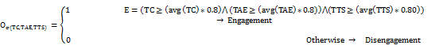

In the above equation, TC denotes total clicks and TAE shows the total activities and exercises student completed during the session. TTS denotes the total time students spent in sessions.

Workload: This variable shows the student workload during the course session and is related to how many activities and exercises the student complete. The literature also includes multiple definitions of workload. For example, workload can show the amount of work assigned to a particular student over a particular duration (Yusoff et al., 2010). Alternatively, workload can represent the pressure on a student due to the syllabus requirements and assessments (Entwisted and Ramsden, 1983). The session that is most difficult for the student is not beneficial for the student and they cannot obtain a high score in the session. The workload label is assigned to student records according to the following rules:
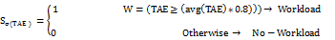

where TAE represents the total activities and exercises completed during the course session in Deeds.
Difficulty: This variable demonstrates the difficulty students experienced in a session. We used the following rule to assign labels to the student records.
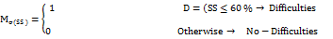
where SS denotes session scores
Loyalty: This value shows indicates how much students like the web-based system. Multiple definitions of loyalty exist in the literature. For example, according to Sim (2011), loyalty means a positive attitude toward higher education. In marketing, loyalty denotes a customer who purchased another product from a previously purchased brand or shops at a location often; such customers are considered loyal to that brand or shopping location (Financial Times, nd). In this study, student loyalty is determined by a student’s per-day visits to Deeds and calculated as follows:

where PDA denotes a student’s per-day visits to the Deeds system and TOA denotes the total on task activities a student performed during the session.
Beneficial:- The measure of the beneficence of the web-based system assigned to a student for students who achieved a high grade. Through data discretization, we convert this numerical attribute into categorical form because such transformation is easier for the instructors to interpret. Different types of discretization methods exist, but we used the manual method of discretization. In the current study, the label (beneficial) is determined based on student session scores. When a session is beneficial, the student achieved a high score (score >=80%). When a session is non-beneficial, the student experienced difficulty during the session and did not achieve a high score. Thus, for sessions beneficial to the student (label=1), the student achieved a high score in the session (score >80%); otherwise, the session will be non-beneficial for that student (label=0).

4.1.2 Data and classification technique

The current study used Deeds log data. Each student’s records include four types of input variables (engagement, workload, difficulty, and loyalty). To build the predictive model for session beneficence, each record is assigned by label (i.e., beneficial or non-beneficial). The details were discussed earlier, in the section “Data discretization and label assignment”.
The main purpose of this predictive model is to predict students beneficial sessions and find which session is most beneficial for the student. This instructor can then use this model to find which sessions are more beneficial based on course materials, activities, and exercises.
To build the current study prediction system, we compared the performance of ML models (i.e., LR, GBT, DL, RF, GLM and NB.)
The LR is a customized linear regression model whose prediction ranges between (-∞ and ∞), and whose predicted probability is between 0 and 1 (Sharma et al. 2014). The GBT the best general-purpose is ML algorithm for solving classification and regression problems. The GBT generates a prediction model by combining the predictions of weak predictive models (en.wikipedia.org/wiki/Gradient_boosting), and the GBT results can be interpreted easily. DL is an ML algorithm with a complex architecture (Schmidhuber, 2017) containing processing layers, which, in turn; contain neurons (also called processors). The neurons process the input data in a parallel fashion. A RF is a widely used classification technique. An RF is also an ensemble method for regression and classification problems (https://en.wikipedia.org/wiki/Random_forest). RF is a good choice for high dimensional data because it has good performance when faced with missing values, and it can address both continuous and categorical data (Ali et al., 2012). The GLM refers to conventional linear regression models which also estimate the continuous response variable from categorical input variables. It also composed of multiple linear regression and ANOVA. The NB classifier is based on Bayes’ theorem. It is a simple probabilistic ML algorithm. NB requires only a small amount of data for training, and its results can be easily understood.
To increase the performance of the current study classifiers, we used an ensemble method. The ensemble learning method is a powerful way to improve the performance and stability of ML models. We also used an ensemble method to evaluate the performances of the current study models. Using ensemble methods, we can combine multiple models to solve a particular real-world problem (Amrieh et al. 2016). Multiple techniques are used in ensemble learning, for example, boosting, bagging, voting, stacking and end notes.

5. Experiments and Results

In this section, we classify students in different sessions using the ML classifiers described above and the input features described above. We used the Rapid Miner tool and regression analysis to build the learning models and answer the current study research questions.

5.1 Design of the predictive models and experimental setups

The current study used Deeds log data representing 107 students who participated in 4 sessions of the digital design course. Each “chapter” of the digital design course is taught in its own session. The current study used the Rapid- Miner tool and the statistical package for the social sciences (SPSS) (https://www.ibm.com/products/spss-statistics) to develop the predictive models and perform regression analyses. We selected different parameters to manage the quality of experiments. The input features of the current study are a student’s engagement, workload, difficulty, loyalty and output variables, representing both beneficial and non-beneficial session results. The regression analysis was performed between student engagement, workload, difficulty and loyalty and the session scores.
To reduce the over fitting problem of the models, we used a 10-fold cross-validation method when conducting the experiments. We used all the session records to train and test the models. In total, there were 423 student records in the study dataset. In 10-fold cross-validation, the entire dataset is divided into 10 subsets. Nine subsets are used to train the ML models, and the remaining set is used for testing.
The LR model achieved its best performance using the default parameters for LR in Rapid- Miner, which are solver=Auto; and missing value handling=mean imputation. The RF settings for these experiments are the number of trees=10; criterion=gain_ratio; max depth=20; and confidence=0.25. The DL settings for these experiments are activation=rectifier; epochs=10.0; and training samples per iteration=-2. The GBT settings are number of trees=20; maximal depth=5; min rows=10.0; min split improvement=0.0; and number of bins=20. The GLM settings are family=auto; and solver=auto.

5.2 Performance measurements

To compare the performance of the current study model, we used four metrics, accuracy, recall, receiver operating characteristic (ROC) curve, and kappa. The accuracy shows the percentage of correctly classified items. Recall shows the ratio between the correctly predicted beneficial session and all sessions that are beneficial in our dataset. The ROC curve plots the true positive (TP) rate against the false positive (FP) rate. For a model whose prediction is good, the area under the curve (AUC) value is closer 1, while a poorly performing model has an AUC value closer to zero. Kappa represents the degree to which the model is better than chance (Mills et al. 2014). When the model’s performance is good, its kappa value will be near 1, and when the model performance is poor, its kappa value will be near zero.
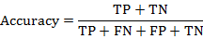 (4)
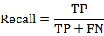 (5)
Note: true positive (TP); true negative (TN); false negative (FN); false positive (FP)

5.3 Results

During web-based system session, do engagement, difficulty, workload, and loyalty have significant impacts on session score?

To explore this question, we performed a regression analysis to find the factors that affect the student’s scores in sessions. A regression analysis predicts the value of a dependent variable based on an independent variable. In regression analysis, R represents the strength of the linear relationship between the dependent variable and the independent variables. The results are presented in Table 1.
Table 1. Regression analysis between student engagement, workload, difficulty and loyalty and score
 | Dependent | Independent
Session# |  | Significance | Engagement | Workload | Difficulty | Loyalty
Sess: 1 | S. Score | R | 0.418** | 0.773** | -0.891** | 0.764**
Sess: 1 | S. Score | P | 0.000 | 0.000 | 0.000 | 0.000
Sess:2 | S. Score | R | 0.077 | 0.079 | 0.145 | 0.068
Sess:2 | S. Score | P | 0.429 | 0.421 | 0.136 | 0.484
Sess:3 | S. Score | R | 0.456** | 0.550** | -0.948** | 0.531**
Sess:3 | S. Score | P | 0.000 | 0.000 | 0.000 | 0.000
Sess:4 | S. Score | R | 0.648** | 0.655** | -0.864** | 0.655**
Sess:4 | S. Score | P | 0.000 | 0.000 | 0.000 | 0.000
Note: An asterisk (*) indicates a correlation significant at the 0.05 level (2-tailed). Features with large correlation coefficients (P >0.05) are not labeled with an asterisk. Features significant at the P <0.05 level are indicated by an asterisk (*), and features significant at the P<0.01 level are indicated by double asterisks (**); Score (Session Score).
Table 1 shows that student engagement, workload, difficulty and loyalty (P<0.05; P<0.05, P<0.05, respectively) strongly affected the student session score in sessions 1, 3, and 4. One possible explanation for this finding is that students who are highly engaged during the session will receive a high score in session exercise marks and indicate that students in the session will show interest in reading the course material and solving the course exercises. student whose exhibit more loyalty during the session regularly visit the Deeds system during sessions to solve session problems; as result, they tend to achieve high scores in the session.
Additionally, the difficulty of the session is negatively correlated with the session score; we can conclude that when the difficulty of a session increases, student performances in that session will decrease.
One possible explanation for these results is that instructors can increase session scores by controlling these independent variables. The regression analysis results show that the students are interested in the course material and exercises in sessions #1, 3, and 4; thus, they improve their skills. The results further indicate that increasing student engagement and loyalty can positively affect the course completion rate: those sessions which engender more engagement and loyalty will help students complete the course.
In contrast, in session #2, student engagement, difficulty, loyalty, and workload are not correlated with the students’ session scores. We hypothesize that students had less interest in the session activities, in reading the course materials and completing the exercises in this session. One possible explanation for this is that the session #2 topic or materials are difficult for students who did not achieve significant scores.
By identifying this problem, the instructor can consider, for example, why sessions #1, 3, and 4 engagement, workload, loyalty and difficulty affect student session scores more, and why the session #2 student input features do not affect the students’ session scores. One cause may be that the content of sessions #1, 3, and 4 are more effective than that of session # 2. Another possible cause might be that in session 2, the students performed more off-task activities than in sessions #1, 3, and 4.

Finally, we can conclude that sessions #1, 3, and 4 are beneficial and that they improve students’ knowledge compared to session #2. This type of analysis helps instructors to determine which course interventions and strategies are needed for each session of a web-based system. Furthermore, it functions to give instructors feedback concerning their courses.

Is it possible to use the ML approach to identify the beneficial sessions in an e-learning course?

To explore this question, we built ML classifiers to predict session beneficence using student interaction data. Table 2 shows the performance results of the ML methods. From Table 2, it can be seen that the accuracy of DL and RF is greater than that of the other classifiers. The DL and RF models achieved accuracies of 82.44% and 82.67%, respectively. An accuracy of 82% means that the model correctly classified 254 of the 330 beneficial students and incorrectly classified 76 students. However, due to the class imbalance problem, using only accuracy as a metric cannot guarantee that a classifier has achieve the best performance (Thomas and Jayagopi, 2017). Therefore, we also use other metrics such as AUC, recall and kappa value. The recall scores for the DL and RF models are 77.73% and 78.04%, respectively. Furthermore, Figure 2 demonstrates that the RF and DL models achieved better AUC values than did the other models in the study.
Our results show that the RF and DL models successfully predict students for whom a session is beneficial. Additionally, RF and DL find beneficial sessions with high confidence.

Table 2. Study model performances without ensemble method
Models | Acc (%) | Recall (%) | Kappa
NBC | 78.91 | 76.25 | 0.541
GLM | 82.21 | 77.66 | 0.595
LR | 81.98 | 77.47 | 0.590
DL | 82.44 | 77.73 | 0.598
GBT | 74.10 | 66.99 | 0.370
RF | 82.67 | 78.04 | 0.604

We further applied the ensemble method to the current study classifiers to increase the accuracy of the models. Bagging is a popular ensemble learning method that is integrated with ML classifiers. The bagging + DL accuracy, recall and kappa are 82.67% and 78.04% and 0.604, respectively. This result shows that the accuracy of Bagging +DL is better than that of DL alone. The results also showed that the performances of the other models were not affected by applying the bagging method.
Based on the results of the experiments in this study, DL and RF are the most appropriate classifiers to identify beneficial sessions for students using Deeds. To further investigate which sessions are significant for students, we used the RF classifier because it obtained a performance in the current study. First, we trained the RF classifier on the data for session #1 and tested it on the data from the other sessions. Then, we trained the RF classifier on the data for session #4 and tested it on session #1 data. The results are shown in Figure 3, which shows that session #1, session #3 and session #4 are beneficial for the student because in those three sessions, the student achieved maximum scores above 80%.
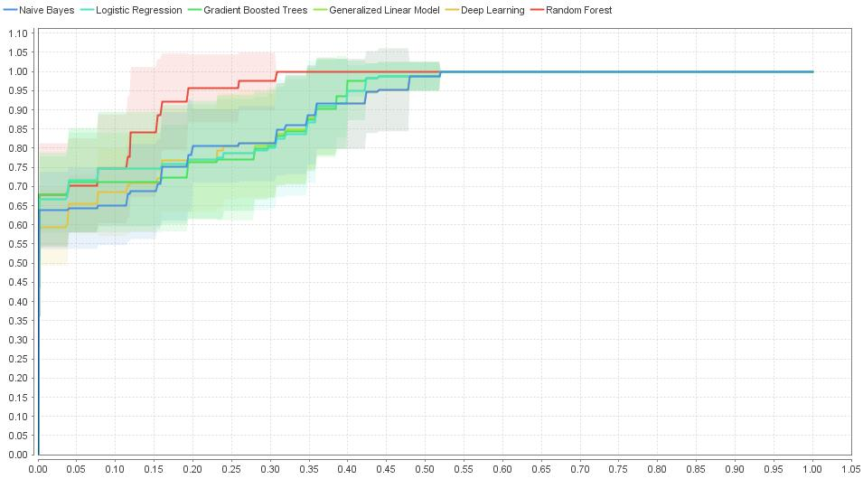
Figure 2. ROC performance comparison of current study models

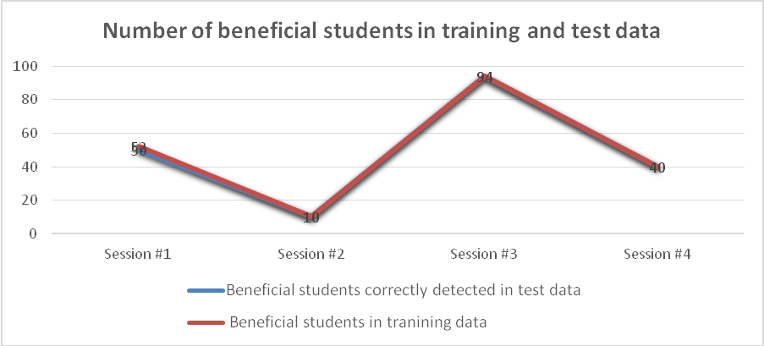
Figure 3. The number of beneficial students detected by training and testing data detected in different Deeds sessions.

The important question the current study classifiers address is finding the beneficial sessions based on Deeds interaction data. Because web-based systems include large numbers of students, asking instructors to manually assess session beneficence is a difficult and nonrobust approach.

5.4 The application of the current study model

Teaching in the web-based learning system is a difficult task, required daily monitoring and understand how the student interacts with their course content. The web-based system provides a large amount of student interaction data. Although, extract meaningful pattern form these data are a time-consuming task. This study model provides a tool which identifying students’ perceptions of a course session or week is important because it affects the student dropout rate. There are many reasons why course sessions or weeks may not be beneficial. One important reason is that the material taught in a session may not be appropriate for improving students’ skills; another possible explanation is that the topic taught in this session is difficult to understand; a third reason is that the instructor’s teaching method is not appropriate; and fourth, the exercises in this session are too difficult.
This model will allow the instructor to design new strategies for improving the course session material and teaching style. Our approach can automatically analyze different session data to provide instructors with feedback on different course materials. Figure 4 shows the scenario of the current study.
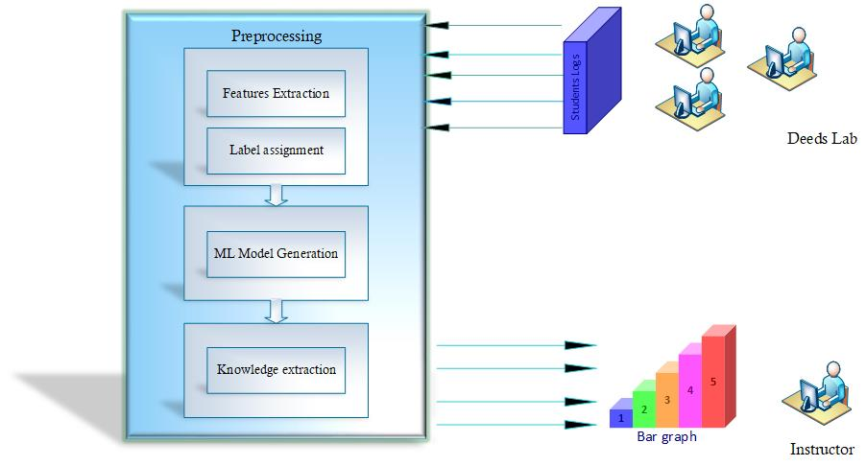

Figure 4. Current study model scenario

Conclusions and Future Work

Collecting knowledge about e-learning system sessions or weeks is important for both instructors. In the current study, we used data from Deeds logs for four sessions (#1 to #4) to develop a system that identified beneficial sessions. These data contain hidden knowledge that instructors can use to find the significant student sessions. These data are used as input to the ML classifiers, which classify the student sessions based on their properties from the logs. We found that a strong relationship exists between student scores and engagement and loyalty for the task activities in the learning session. Additionally, the results show that RF and DL are suitable ML models for finding beneficial sessions during the e-learning course. According to the current study results, session #2 is not appropriate for students using Deeds because that session includes unimportant activities or material. The knowledge obtained in this study can help instructors design more efficient sessions or weeks for students using e-learning systems.

6.1 Limitation and Future work
The current study used only student interaction data from a web-based system. However, session or week beneficial can also depend on others factor such as family commitment, study environment, and teaching style. These aspects require further investigation.

Data Availability
The current study data are publicly available online (https://archive.ics.uci.edu/ml/datasets/Educational+Process+Mining+%28EPM%29%3A+A+Learning+Analytics+Data+Set) for research purposes. Ethical clearance was granted by the University of Genoa, Italy. No personal information (e.g., name or address) of the participants was included in this study.
Conflicts of Interest
The authors have no conflicts of interest
Funding Statement
This work is supported by the National Natural Science Foundation of China (Nos.61 572434, 91630206) and the National Key R&D Program of China (No.2017YFB0701501).

Copy from other papers
References
Jordan K (2014) Initial trends in enrolment and completion of massive open online courses. Int Rev Res Open Distance Learn 15(1):133–160
Arnold A., Scheines R., Beck J. et al (2005) Time and attention: students, sessions, and task. In: Proceeding of the AAAI workshop educational data mining, pp62-66.
Ali J and Khan N et al (2012) Random forests and decision trees. IJCSI International Journal of Computer Science 9(5), pp272-278.
Atherton M, Shah M, Vazquez J et al (2017) Using learning analytics to assess student engagement and academic outcomes in open access enabling programmes, Open Learning 32(2).pp119-136.
Coates, H. (2006) Student engagement in campus-based and online education university connections. London: Routledge.
Casey, K., & Gibson, P (2010) (m)Oodles of Data Mining Moodle to understand student behavior. In: International conference of engaging pedagogy (ICEP10): pp.61-71
Cuesta L (2010) The Design and Development of Online Course Materials: Some Features and Recommendations. PROFILE Issues in Teachers' Professional Development, 12(1), pp.181-201.
Entwistle N., Ramsden P. (1983) Understanding student learning. London: Croom Helm
Financial Times. (n.d). Definition of customer loyalty. Retrieved September 12,2018, from http://lexicon.ft.com/Term?term=customer-loyalty
Greenland, S.J., & Moore, C. (2014). Patterns of online student enrolment and attrition in Australian open access online education: a preliminary case study. Open Praxis, 6(1), 45–54
Guo WW. (2010) Incorporating statistical and neural network approaches for student course satisfaction analysis and prediction. Expert System with Application. Pp3358-3365.
Hussain S., ÇİFÇİ MA, Tamayo JD, Safdar A (2018) Big Data and Learning Analytics Model. International Journal of Computer Sciences and Engineering, 6(7), pp654-663.
Ku, D., & Chang, C. (2011). The effect of academic discipline and gender difference on Taiwanese college students' learning styles and strategies in web-based learning environments. Turkish Online Journal of Educational Technology, 10(3), 265–272
Kardan AA, Sadeghi H., Ghidary SS et al (2013) Prediction of student course selection in online higher education institutes using neural network, Computer & Education 65: pp1-11
Krnel D., Barbra B (2009) Learning and e-materials. Acta Didactica Napocensia, 2(1): pp.97–108.
Murphy P M, and Aha D W. UCI Repository of Machine Learning Databases, (Machine Readable Data Repository). 1995 Irvine, CA: Dept. Inf. Comput. Sci., Univ. California
Mills, C., Bosch, N., Graesser, A., & D’Mello, S. (2014) To quit or not to quit: Predicting future behavioral disengagement frothe m reading pattern . In Intelligent Tutoring System, Lecture Notes ,8474,19-28
Mutahi J., Kinai A., and Bore N. (2017) Studying engagement and performance with learning technology in an african classroom, In: Proceedings of the Seventh International Learning analytics and Knowledge Conference, pp148-152.
Darmody M., Smyth E., and Unger M (2008) Field of Study and Students' Workload in Higher Education: Ireland and Austria in Comparative Perspective, International Journal of Comparative Sociology 49(5), pp. 329 – 346, https://doi.org/10.1177/0020715208093080
Richardson, M., Abraham, C., & Bond, R. (2012). Psychological correlates of university students' academic performance. A systematic review and meta-analysis. Psychological Bulletin, 138,353–387
Sharma, A., Prince, S., Kapoor et al (2014) PPS-Placement prediction system using logistic regression, In. IEEE International conference on MOOC innovation and technology in Education (MITE):pp.337-341.
Stovall I, (2003) Engagement and online learning. UIS community of Practice for ELearning. http://otel.uis.edu/copel/Engagemetn and online learning.ppt
Schmidhuber J (2017) Deep learning in neural networks: An overview. Neural Netw. 61:85–117
Scheuer, O., & Zinn, C.(2007). How did the e-learning session go? The student inspector. In R. Luckin, K. R. Koedinger, & J. Greer (Eds.), Proceeding of the 2007 Conference on Artificial Intelligence in Education: Building Technology Rich Learning Contexts That Work (pp. 487-494). Amsterdam, Netherlands: IOS Press.
Sim LL. (2011) Determinants of students’ satisfaction and student loyalty in college x:a case study. Research report in partial fulfillment of the requirements for the degree of Master of business administration.
Thomas C, Jayagopi DB (2017) Predicting student engagement in classrooms using facial behavioral, In ACM international workshop on multimodal interaction for education. Pp8
Whitelock D., Thorpe M., Galley R (2015) Student workload: a case study of its significance , evaluation and management at the open university, Distance E ducation 36(2):161-176
Vahat, M., Oneto, L., Anguita, D., Funk, M., Rauterberg, M., (2015) A learning analytics approach to correlate the academic achievements of students with interaction data from an educational simulator, 2015 In European Conference on Technology Enhanced learning.2015:11; 352-366.
Yusoff, M.S.B., A.F. Abdul Rahim and M.J. Yaacob (2010) the development and validity of the Medical Student Stressor Questionnaire (MSSQ). ASEAN J. Psychiatry, 11: 231-235

